Bootstrap Forest for Profits(in millions, USD)

Specifications

Target | Profits(in millions, USD)
Validation Column: | Validation
Number of Trees in the Forest: | 100
Number of Terms Sampled per Split: | 6

Training Rows: | 220
Validation Rows: | 54
Test Rows: | 0
Number of Terms: | 8
Bootstrap Samples: | 220
Minimum Splits per Tree: | 10
Minimum Size Split: | 5

Overall Statistics

 | RSquare | RASE | N
Training | 0.688 | 5649.3293 | 220
Validation | 0.703 | 4929.7375 | 54

Number of Trees
100

Individual Trees | RASE
In Bag | 4651.917
Out of Bag | 8850.944

Cumulative Validation
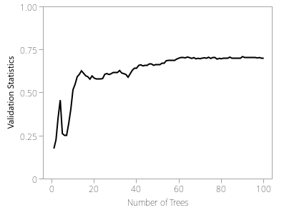

Actual by Predicted Plot

Training Set | 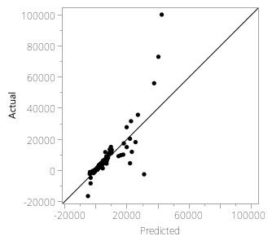
Validation Set | 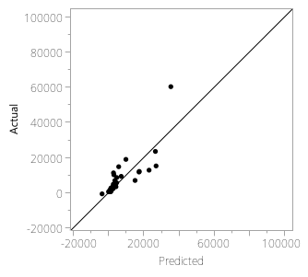

Column Contributions

Term | Number of Splits | SS |  | Portion
Valuation(in millions, USD) | 519 | 5518173015 |  | 0.5801
Revenue(in millions, USD) | 848 | 2201439883 |  | 0.2314
Profits(% of Sales) | 1090 | 1177947266 |  | 0.1238
Employees | 289 | 241596703 |  | 0.0254
environment_score | 168 | 143438182 |  | 0.0151
social_score | 200 | 139111179 |  | 0.0146
total_score | 145 | 50312194.9 |  | 0.0053
governance_score | 136 | 40433117.5 |  | 0.0043

